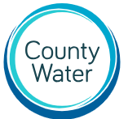

Wholesale Charges 2022/23
Statement of Assurance

This Assurance Statement for County Water Ltd covers the area of Heyford Park, Upper Heyford.

This statement is made by County Water Ltd. The sewerage undertaker for the site above, to comply with its Licence Conditions and in line with the Authority’s Wholesale Charging Rules.

I confirm the following:

- County Water Ltd complies with its legal obligations relating to the wholesale charges it has published;

- The board has assessed the effects the wholesale charges have on sewerage licensees (as a whole or in groups) who are retailing wholesale services and on customer occupying eligible premises (as a whole or in groups) for a range of customer types. The board recognises that the wholesale tarrifs do not increase customer bills by more than 5%.

- County Water has procedures in place to ascertain accurate publication of its wholesale charges, which includes up to date recordings of data;

- County Water has consulted with relevant stakeholders in a timely and effective manner on its wholesale charges;

- No final wholesale charges are significantly different from the indicative wholesale charges published for the same period.

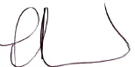

_____________________
Paul Silver
Chief Executive Officer

